KLEOPATRA kick-off meeting
15.06.2023, Wrocław, Poland
Venue:
Department of Pathogen Biology and Immunology, University of Wroclaw, Poland
ul. Przybyszewskiego 63-77, 51-148 Wroclaw; room 206, second floor

9:00-9:15 Introduction – Zuzanna Drulis-Kawa
9:15-9:30 Lab presentation - UWr, Zuzanna Drulis-Kawa
9:30-9:45 Lab presentation – KUL, Rob Lavigne
9:45-10:00 Lab presentation – SU, Regis Tournebize
10:00-10:15 Lab presentation – IMB, Joachim J. Bugert
10:15-10:30 Lab presentation - BfR, Jens A. Hammerl
10:30-10:45 Lab presentation – HUJI, Ronen Hazan
10:45-11:00 Lab presentation – INVITRIS, Kilian Vogele

11:00-11:15 coffee break

WP presentation/interaction with partners/timeline/resources/
11:15-11:30 WP1. ONE HEALTH K. pneumoniae strains monitoring – BfR as WP leader, Jens A. Hammerl
11:30-11:45 WP2. Elaboration of phage preparations – IMB as WP leader, Joachim J. Bugert
11:45-12:00 WP3. Application of CDs in the phage-host interplay – UWR as WP leader, Zuzanna Drulis-Kawa
12:00-12:15 WP4. In vivo (mouse model) evaluation of most top AB/phage/CD combinations – SU as WP leader, Regis Tournebize
12:15-12:30 WP5. The development of new mathematical models for optimisation of antimicrobial combinations in treatment protocols and companion diagnostics – KUL as WP leader, Cedric Lood

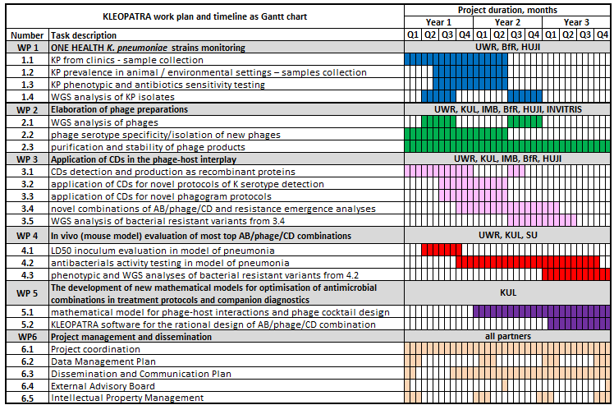

12:30-14:00 Lunch

14:00-14:15 Reporting - Zuzanna Drulis-Kawa
14:15-14:45 CA, External Advisory Board election, and meeting schedule – Zuzanna Drulis-Kawa
14:45-15:15 Dissemination and Communication Plan & website, Kleopatra logo, email footnotes - Tomasz Olszak, discussion
15:15-16:00 Data Management Plan – Tomasz Olszak
16:00-17:00 IP management plan, MTA agreement, strains/depos, and phages selection for distribution

19.00 Dinner (city center)

